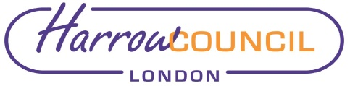
Report for: | Cabinet
Date of Meeting: 23 June 2022
Subject: Extension Household Support Fund

Key Decision: | Yes - it affects the whole Borough and spend over £500k  .
Responsible Officer: | Charlie Stewart - Corporate Director, Resources
Portfolio Holder: | Councillor Stephen Greek - Portfolio Holder for Performance, Communications & Customer Experience
Exempt: | No
Decision subject to Call-in: | Yes
Wards affected: | All
Enclosures: | Appendix 1: Household Support Fund Policy Document  Appendix 2: Equality Impact Assessment

Section 1 – Summary and Recommendations
The Government announced in March 2022 that an extension to the previous Household Support Fund (HSF) will be made available to Councils in England to support those most in need to help with the rising cost of living. This funding will cover the period 01 April 2022 to 30 September 2022 inclusive.

Harrow Council has been allocated an indicative grant of £1,476,707, which must be spent by 30 September 2022. The extended Household Support Fund’s main objective is to provide support to vulnerable households with significantly rising living costs, with a greater emphasis on offering support with energy bills, whilst food and water bills also remain priorities.

This paper proposes how Harrow Council would spend the indicative Household Support Fund before 30 September 2022.

Recommendations:

Cabinet is requested to:

- Approve the allocation of the extension of the Household Support Fund as set out in this report;
- Approve the purchase of vouchers for the elements identified in this report through the Post Office Voucher Scheme;
- Approve the award of contract to the Post Office for a value of £511,250 using Regulation 32 (2) (C) of the Public Contract Regulations 2015 which permits contracting authorities to award public contracts by negotiated procedure without prior publication;
- Delegate to the Corporate Director Resources in consultation with the Cabinet Member for Performance, Communications and Customer Experience to make technical scheme amendments to ensure the scheme meets the criteria set by the Government and the Council and remains within the indicative grant level; and
- To grant delegation to make technical changes to the proposed scheme to the Corporate Director – Resources in consultation with the Cabinet Member for Performance, Communications and Customer Experience, should the grant level or the delivery plan submitted change.

Reason: (for recommendations)
The recommendations in this report meet the essential criteria for the grant as set out by DWP. The Council have considered where best to focus the funding and the proposals provide a balance of support together with focus so that the funding is not spread too thinly. The proposal for the eligible spend covers the following:

- Free school meals, which have previously been found to provide effective support to vulnerable households with children.
- Vouchers for households with children in receipt of housing benefit which can be redeemed against an energy or utility bill and/or costs associated with food or other related essential costs
- Help Harrow. This is a joint venture with the voluntary and community sector, which has shown to be effective in providing essential food support quickly and effectively to any vulnerable household.
- Support with rent arrears to help stop vulnerable households spiralling into acute difficulties, avoid court action and secure their tenancy.
- Pensioners on Council Tax Support and Pension Credit will be offered a voucher which can be redeemed against an energy or utility bill and/or costs associated with food and other related essential costs.

Section 2 – Report

Introductory paragraph

Harrow Council has been allocated an indicative grant of £1,476,707 to deliver the extension Household Support Fund which has subsequently been approved and sets the maximum the Council can spend on the fund. Although the grant is indicative, and the Council was required to provide a delivery plan to DWP by 29 April, the expectation is that the grant level and the delivery plan as submitted would not change.

The allocated grant must be spent by 30 September 2022 and local authorities have been asked to start making immediate preparations to administer the grant. As the cost of living is currently increasing getting support to Harrow’s most vulnerable residents as quickly as possible is of paramount importance.

The DWP have provided the guidance which sets the framework within which the fund must be delivered – Household Support Fund (1 April 2022 to 30 September 2022): final guidance for county councils and unitary authorities in England - Updated 29 April 2022. This requires the following:

- At least one third of the total funding to be ring-fenced to support households with children,
- at least one third to be ring-fenced to support pensioners, and
- up to one third of the total funding to other vulnerable households.
- Eligible spend includes energy and water and food, which the fund should be primarily used for. The latter can be supported in kind or through vouchers or cash. Funding can also be used for essentials linked to energy and water and wider essentials. Housing costs should only be supported in exceptional cases of genuine emergency.
- Reasonable administrative costs can also be covered.
- The fund cannot be used for advice services including debt advice or mortgage costs.
- Eligibility should not be conditional on being in employment or self-employment.

Authorities have the flexibility within the scheme to identify which vulnerable households are in most need of support and apply their own discretion when identifying eligibility. In doing so they should particularly consider households who cannot increase their income through work. Authorities can request applications for support or can proactively identify households who may benefit or can take a mixture of the two approaches. Where Authorities are proactively identifying households, they should consider how they can ensure that they are focusing on those in the most need to prevent escalation of problems.
Local authorities have been asked to make preparations to administer the grant and to put arrangements in place as quickly as possible to support vulnerable households throughout the grant period. Harrow’s draft delivery plan was submitted to the Department of Work and Pensions (DWP) on the 29 April, as requested, and has been subsequently approved by the DWP.

Options considered

The recommendations seek to maximise the impact of this funding for households most in need in the Borough. Different options of either spreading the funds more thinly to a greater number of households or giving a higher value award to less households were considered. The recommended options provide a balance of these approaches, limited by the available data, for example limited availability of email addresses. It also seeks to use proven methods of delivering focused funding to vulnerable families and residents such as Free School Meals and Council Tax Support.

Set out below is the recommended split of funding across different streams. The value of spending for each may alter depending on caseloads at the point data is extracted through the period the scheme is running. The intention is to ensure all funding is spent by 30 September 2022 with the allocations as illustrated below.

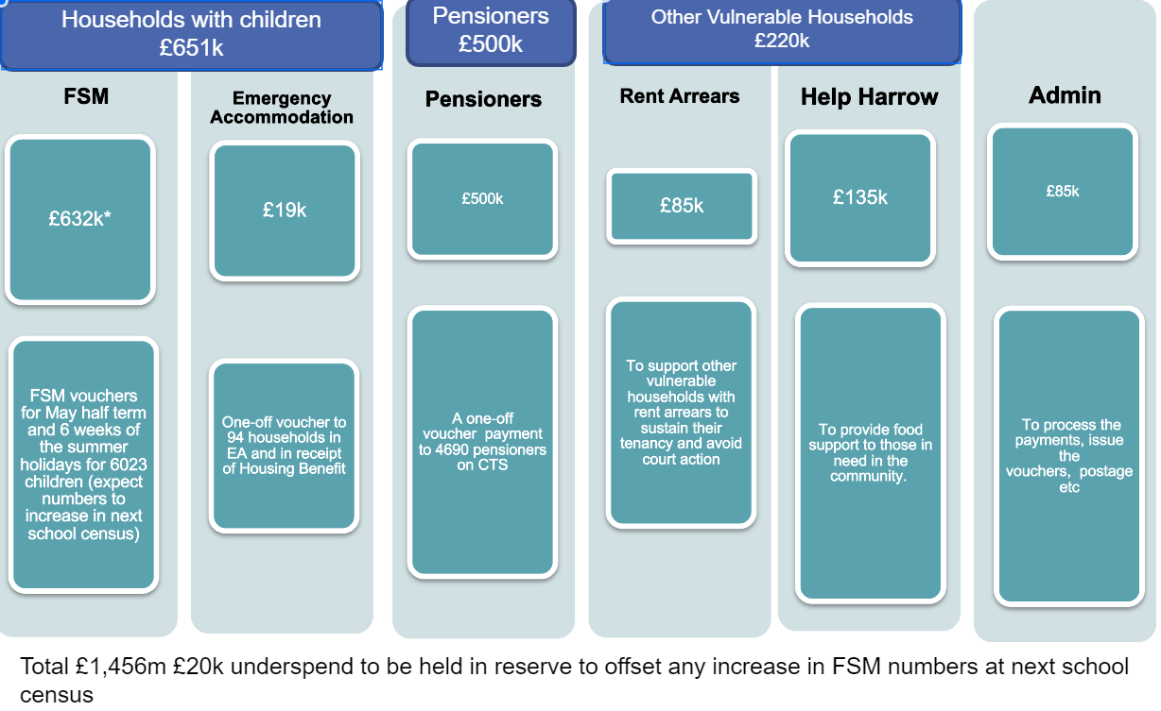

More detail about each of these elements is set out below. If these allocations are agreed, then there is a reserve of £20,707, which would be held to see how spend progresses and then allocated within the framework as appropriate. It is proposed that authority to allocate it within the framework is delegated to the Corporate Director – Resources in consultation with the Cabinet Member for Performance, Communications and Customer Experience.

Households with Children

Free School Meals

The provision of free school meals (FSM) to vulnerable households during the holidays from October 2020 through to Easter 2022 has been found to be incredibly effective in identifying those families in most need, and there is no other viable alternative currently. Schools already have voucher systems set up for those parents with children on free school meals, making the Council’s schools funding a very efficient and effective way of giving financial support to families whose children qualify for free school meals.

The first HSF a total of £622k was spent on FSM for 6 weeks (including a £10 Christmas top up). The number of eligible children increased by 330 in that time.​ By providing FSM vouchers it frees up other household income to cover other costs to support them more broadly dealing with the 'cost of living' pressures.

FSM provision was recently extended into the May half term, and under this proposal would continue into the summer holidays.

According to the January school census there are 6,023 pupils who will be eligible for FSM. They will each be awarded £3 per day per child for the 6 weeks summer holidays, in addition to the recent May half term provision. Total cost: 6,023x3x35 = £632,415.

Emergency Accommodation

Households with children in emergency accommodation and in receipt of Housing Benefit are proposed to be given an award of £40 a month for 5 months as a one-off payment of £200.
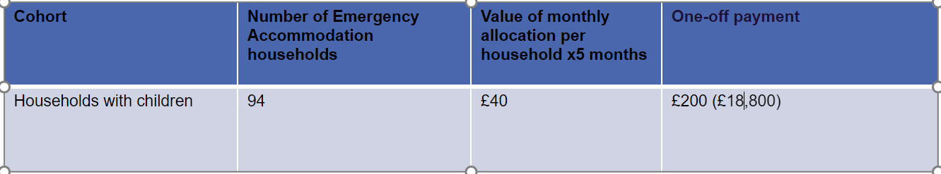

The vouchers will be administered via the Post Office Pay-out Scheme to meet energy cost needs.

Pensioners

As per the DWP guidance at least 1/3rd or £492,000 of the grant must be spent on pensioners. It is proposed to award a one-off voucher payment to 4695 pensioners on Council Tax Support.

Options for flat rate or banded rate have been considered and the option with the greatest impact is to give a flat rate of £105 to all Pensioners on active Council Tax Support. This would cost circa £493k so is within the expectations of a third of the monies being used to support residents of pensionable age.

The approach of issuing vouchers carries a risk that not all vouchers issued will be redeemed, making the required spend on this cohort fall short of the 1/3rd split requirement. We will mitigate this by monitoring redemption rates on a weekly basis and issuing reminder letters, which have proven effective in the previous round in increasing redemption rates and ensuring there is capacity in the Council’s contact centre to answer any enquiries. We would expect a minimum redemption rate of 80%. The value of any unredeemed vouchers by 28 September 2022 would be reprofiled into rent arrears for pensioner households on hardship fund to ensure compliance with the 1/3rd spend criteria. Any decision would be taken in consultation with the Cabinet Member for Performance, Communications and Customer Experience.

Other Vulnerable Households

Rent Arrears

As per DWP guidance, in exceptional cases of genuine emergency, the funding can additionally be used to support housing costs where existing housing support schemes do not meet this exceptional need​. All other options for support must have been exhausted before an award from the Household Support Fund can be considered, for example Benefits or Discretionary Housing Payments. Awards must not be made for housing support on an ongoing basis or to support unsustainable tenancies. Cases would therefore be considered on an individual basis to understand the long-term impact of clearing all or some of the arrears.

In the previous scheme money was awarded to prevent households from facing court action and put support in place to engage with them to prevent further debts arising​. However, the DWP have been clear in their guidance for this tranche of HSF that funding of advice services is not permitted.

Therefore, it is proposed that the previous arrangement to support households at risk of homelessness from private rented, temporary and council rented accommodation is continued and the following funding is allocated as follows:

£55,000 to council tenants and targeted at single people and those with disabilities;

£30,000 to emergency & temporary accommodation households and targeted at those who are vulnerable.

Help Harrow

It is proposed that as the Community Hub is already in receipt of additional monies from the Council, having been extended until the 30 September 2022, an additional £133k is awarded from HSF that would fund the Hub for another 6 months to offer support to those in need in the community. The Hub, through the Help Harrow project, has been found to be very effective in providing food and other support to a wide range of vulnerable residents. The current funding being used to support this year’s activity from April to September is flexible, so we can use the HSF to cover the period April to September (so it is spent with the grant window), and reprofile the existing funding to cover the period October to March 2023.

Food provision is one of the priorities in the DWP guidance and food is frequently what households present as not being able to afford as they have used money on other essential items. For households with a different need, provision of food may free up money to be used on other items.

Administrative Costs

DWP have allowed Councils to use a reasonable amount of the Household Support Fund to pay for administration of the scheme. The Council will need the following additional resource to manage the grants, issue vouchers and make payments:​

- Housing Support for rent arrears awards - £10k​

- Contact Centre additional capacity – up to £40k​

- Additional business support to administer the vouchers and payments - £10k​

- Voucher admin set up costs (including extracting of data from Council Tax records for pensioner cohort), additional postage and printing of reminder letters - 25k
Ward Councillors’ comments
Not applicable.

Performance Issues

Performance will be tracked through:

- the contract with the Post Office on redemption of vouchers so that we can assure ourselves that the take up from this cohort is maximised;
- Free school meal voucher usage through schools; and
- Help Harrow monitoring information.

Environmental Implications

There are none.

Data Protection Implications

A data protection impact assessment has been completed and as agreement to share any personal data is already sort from residents by CAH and our systems are already data compliant, then there are not considered to be any key data protection risks.

Risk Management Implications
Risks included on corporate or directorate risk register? No

Separate risk register in place? No

The relevant risks contained in the register are attached/summarised below. N/A

The following key risks should be taken onto account when agreeing the recommendations in this report:

Risk Description | Mitigations | RAG Status
Risk of more applicants being in the system resulting in overspend | - FSM – £80k had previously been committed to FSM from the public health reserve. This pot will be retained to cover any FSM overspend due to an increase in the number of children receiving FSM over the course of the HSF scheme.  - Emergency Accommodation – this is a relatively low number of households so low financial impact if number rises.  - Other elements of the scheme – funding is limited to the amount allocated so any increase in demand will not be met.  - The proposal includes a reserve of £20,707, which will be used to top up any elements where demand is higher than forecast. | Amber
Risk of funding not being committed by the September 2022 deadline | - Most elements of the scheme are proactive issue of awards so do not need to be claimed by residents which reduces the risk of underspend.  - Publicity will be undertaken to raise awareness, in particular with partners who are well placed to signpost pensioners to take up the vouchers.  - Any unspent funds are currently being planned to be used to increase the rent arrears allocation to eligible pensioner and vulnerable households. | Green
Full funding not received as a result of DWP determining that spend was not eligible | - Payment of the grant from DWP will be made in arrears after the interim MI return in July 2022 and the final MI return at the end of grant period in October 2022 after the DWP have verified the MI.  - The second will be dependent on DWP being satisfied that the LA’s MI submission evidence eligible spend within the scheme  - Harrow’s approach takes full account of DWP guidance on spend to ensure its scheme is within the framework.  - The scheme proposal has been submitted to DWP in advance of the scheme launching. Further MI will be submitted to DWP regarding actual spend in October 2022. Any feedback from DWP in response to either of these submissions will be considered and implemented as appropriate to ensure the scheme remains compliant.  - There is flexibility within the scheme to adapt it should it be necessary to make changes to the allocation of funding across the different elements once DWP feedback. | Amber
The focus of funding is inappropriate/does not fulfil the fund’s objective and options limited as it is based on limited data. | - Regular review of allocations and spend to ensure update is appropriate.  - Level of funding allocated to different strands of the scheme can be adjusted to ensure scheme remains within funding allocation.  - Harrow’s draft delivery plan was submitted to the Department of Work and Pensions (DWP) on the 29 April, as requested, and has been subsequently approved by the DWP | Green
Funds duplicate existing provision | - Regular review of allocations against outcomes predicted from other grants to ensure there is no or limited overlap. | Green
The approach of issuing vouchers carries a risk that not all vouchers issued will be redeemed, making the required spend on this cohort fall short of the 1/3rd split requirement. | - We will monitor redemption rates on a weekly basis.  - Issue a reminder letter,  - ensure there is capacity in the Council’s contact centre to answer any enquiries.  - We would expect a minimum redemption rate of 80%.  - The value of any unredeemed vouchers by 28 September 2022 would be reprofiled into rent arrears for pensioner households on hardship fund to ensure compliance with the 1/3rd spend criteria. | Amber
Risk of Fraud | - Proven methods of delivering focused funding to vulnerable families and residents such as Free School Meals and Council Tax Support.  - Recipients identified by the Council | Green

Procurement Implications
The Council has already entered into arrangements to support the Community Hub which has had procurement sign off, so as the arrangement here is to utilise a further £135,000, which would be done by contract extension.
The Council will purchase vouchers for elements identified in this report relating to Pensioners on Council Tax Support and those in Emergency Accommodation, using Regulation 32 (2) (C) of the Public Contract Regulation 2015. This is a compliant procurement route to contract with the Post Office Pay-out Scheme for the sum of £511,250.

Legal Implications
The DWP has issued £421million to councils to support those most in need. The funding period covers 1 April 2022 to 30 September 2022 inclusive. The DWP has issued guidance on use of the fund, which sets out eligibility criteria. The funding is being provided under section 31 of the Local Government Act 2003 and local authorities are responsible for setting criteria and administering the fund.

The Council is expected to use a range of data and sources of information to identify and provide support to a broad cross section of vulnerable households. The Council must have a clear rationale or documented policy/framework outlining its approach including defining eligibility and how the scheme is accessed. Receipt or eligibility for other support should be taken into account to avoid duplicating provision where possible.

The Council is permitted to provide a basic safety net to support individuals regardless of their immigration status if there is a genuine care need that does not arise solely from destitution. To evidence this, there should be an assessment of community care needs, serious health problems or a risk to a child’s wellbeing. Individuals with no resource to public funds can be supported in accordance with specific legal powers connected to the aforementioned assessments.

The Council must have effective systems in place to combat fraud. If administration is via a third party, suitable due diligence checks must be carried out to ensure they are viable and able to deliver the scheme. There should be appropriate checks in place to verify the identity of those who are eligible. Any suspected financial irregularity must be reported to the DWP, explaining what steps are being taken to investigate the alleged fraud or other impropriety.

Reasonable administration costs can be recouped from the grant. Such administration costs will be published in the Gov.uk website alongside details of all spend.

Financial Implications
The indicative grant allocation is £1,476,707. The cost of the support fund will be provided within this grant level. The grant allocation is considered unlikely to change.

Equalities implications / Public Sector Equality Duty

An equality impact assessment (EQIA) has been undertaken for this proposal the EQIA concludes that:

There will be a positive impact on those working age benefits recipients, and within those families with children;

There will be a positive impact on those people of pensionable age

There is likely to be a positive impact on pregnancy and maternity

There will be a positive impact on women.

Mitigations are set out in the Equality Impact Assessment.
An updated announcement of the extension of the Household Support Fund will be published on Harrow’s website, which meets the general accessibility criteria.

The Council is also developing a communications and engagement plan, which will be principally aimed at maximising take up by the pensioner group. Activity will include:

- An article in the July edition of Harrow People, which goes to every household in the Borough, indicating that if you are of pensionable age and in receipt of Council Tax support you will have received a letter with a Post Office voucher;
- Engagement with places of worship to build awareness and take up of the Post Office voucher scheme letter, which will be distributed to the pensioner cohort and the households in emergency accommodation; and
- Discussions with the Adult Services Provider Forum and the Carers Network so that those people who work with and support some of our pensioner population can encourage them to use the voucher.

Council Priorities

The Council’s priorities are being reviewed following the local election, but in prioritising the spend profile of the Household Support Fund, the Council is Putting Residents First by maximising the amount of the HSF going into support families directly.

Section 3 - Statutory Officer Clearance
Statutory Officer: Dawn Calvert
Signed by the Chief Financial Officer
Date: 14 June 2022
Statutory Officer: Sarah Wilson
Signed on behalf of the Monitoring Officer
Date: 7 June 2022
Chief Officer: Charlie Stewart
Signed by the Corporate Director
Date: 10 June 2022
Head of Procurement: Nimesh Mehta
Signed by the Head of Procurement
Date: 14 June 2022
Head of Internal Audit: Susan Dixson
Signed by the Head of Internal Audit

Date: 14 June 2022

Mandatory Checks
Ward Councillors notified: NO, as it impacts on all Wards
EqIA carried out: YES
EqIA cleared by: Head of Equality, Diversity and Inclusion (EDI)

Section 4 - Contact Details and Background Papers
Contact: Angelica Stoichkov, Policy Officer, Angelica.Stoichkov@harrow.gov.uk.

Background Papers: None

Call-in waived by the Chair of Overview and Scrutiny Committee
NO

